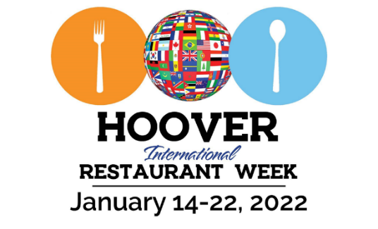

International Restaurant Week January 14th – 22nd

Restaurant Application Form

Business Name______________________________________________

Contact_____________________________________________________

Address____________________________________________________

Phone________________________Email_________________________

Type of Food (Indian, Chinese, Japanese, Mexican Etc)______________

Menu Items ___________________________________

______________________________

______________________________

Pricing ______________________________

Please
- We ask that you create a special menu item or feature something from your current menu
- Train your staff to offer the Restaurant Week Menu when asked
- Promote this menu special on your Social Media
- Share all Hoover International Restaurant Week posts to your Social Media
- Forward your Logo to Mark@contentlogistix.com
- We ask for a check for $100 to Hoover Restaurant Alliance that will go to our selected charities
- Our charities include Adelante Alabama, Hispanic Interest Coalition of Alabama (HICA), Birmingham Chinese Association, The Hindu Temple and Cultural Center, Birmingham Al, Hoover Crescent Islamic Center, Hoover Helps

Please contact David Cohen 205-213-3617, davidg.cohen@hotmail.com

